Here is the user manual for the user to know about the MAW Foundation website. These manual helps you for Creating, editing, deleting, inserting, and removing any pages of any images that you want.

# **User Login**

## User Login:

First of all, the user will get to the login page of the dashboard of website, where they have to enter their Email or username and password for entering to the dashboard for adding, editing or deleting.



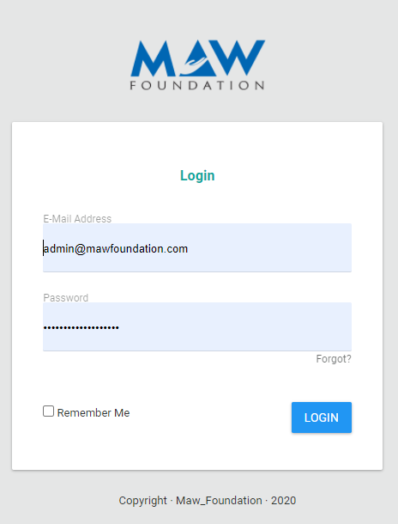

Figure 1: Login page

## User login fail:

Here if the user fails to login and in any case the user forgot the username or password for login then these messages will be shown up.

To test whether the system accepts invalid data while logging in with user credentials.

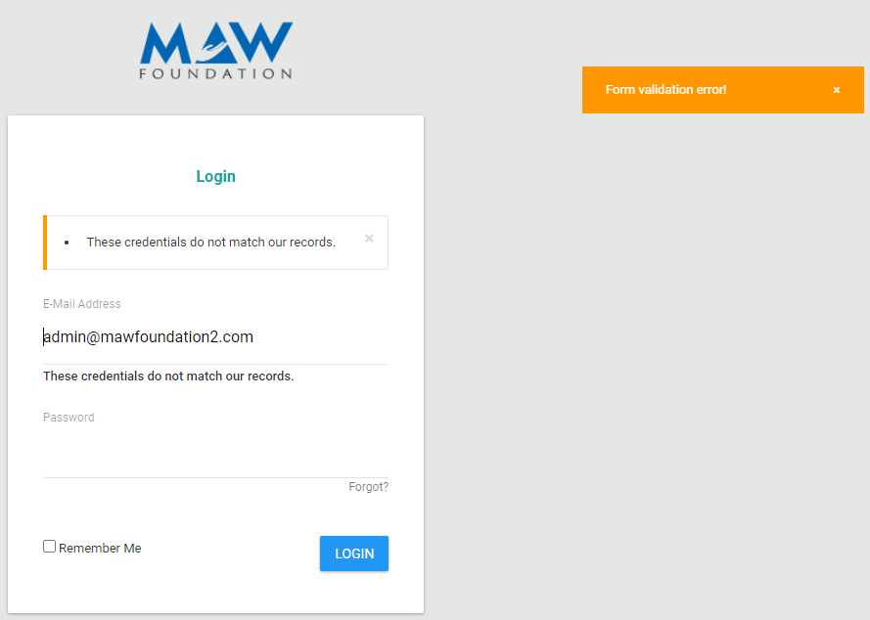

Figure 2: Attempting to log in with invalid data

# **Dashboard admin panel for MAW Foundation**

## Homepage of dashboard:

Here is the first page when you login in to the dashboard of MAW Foundation website.

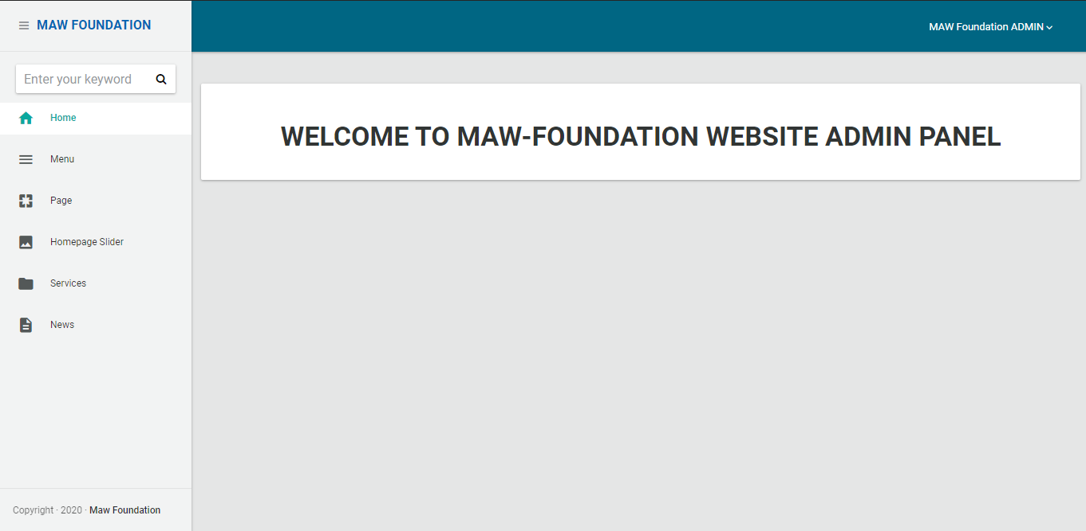

Figure 3: Homepage of dashboard

## Menu Add:

Here by clicking to the menu, you will be access for creating a new menu tab, editing the menu tab, and deleting the menu.

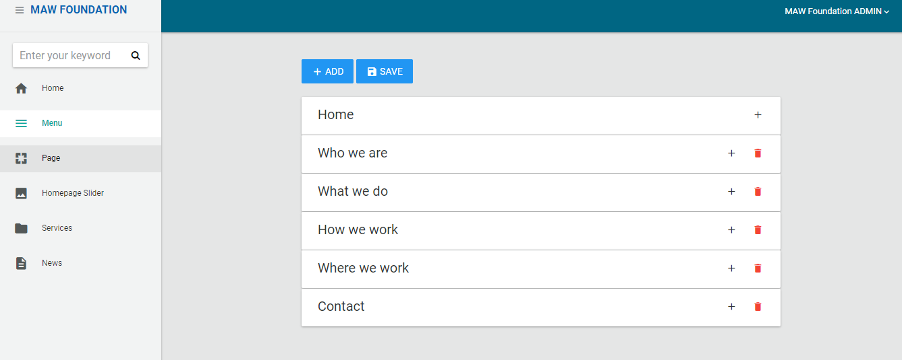

Figure 4: Menu tab

For adding a new menu, you can click to “ADD” button and add you required menu name and page if required.

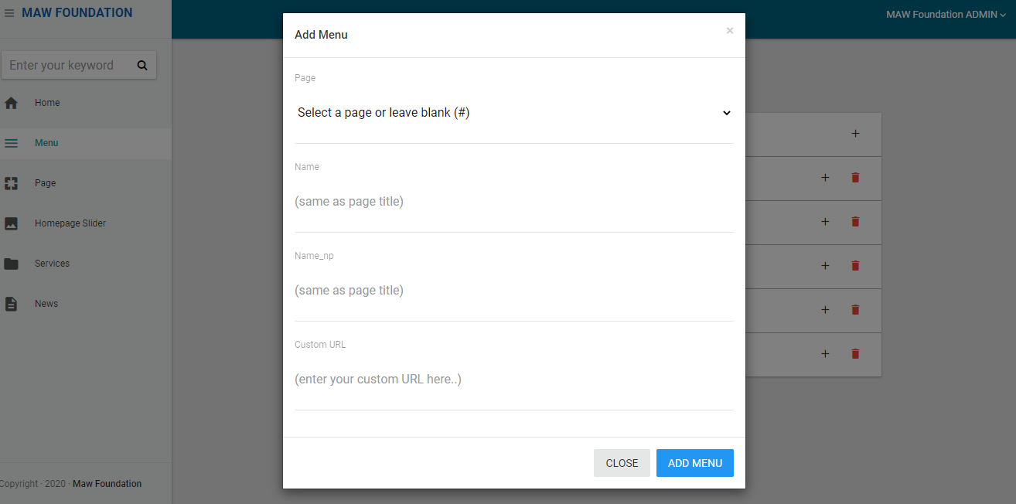

Figure 5: Adding menu

## Page Add:

Here by clicking to the page, you will be access for creating a new page, editing the page tab, and deleting the page.

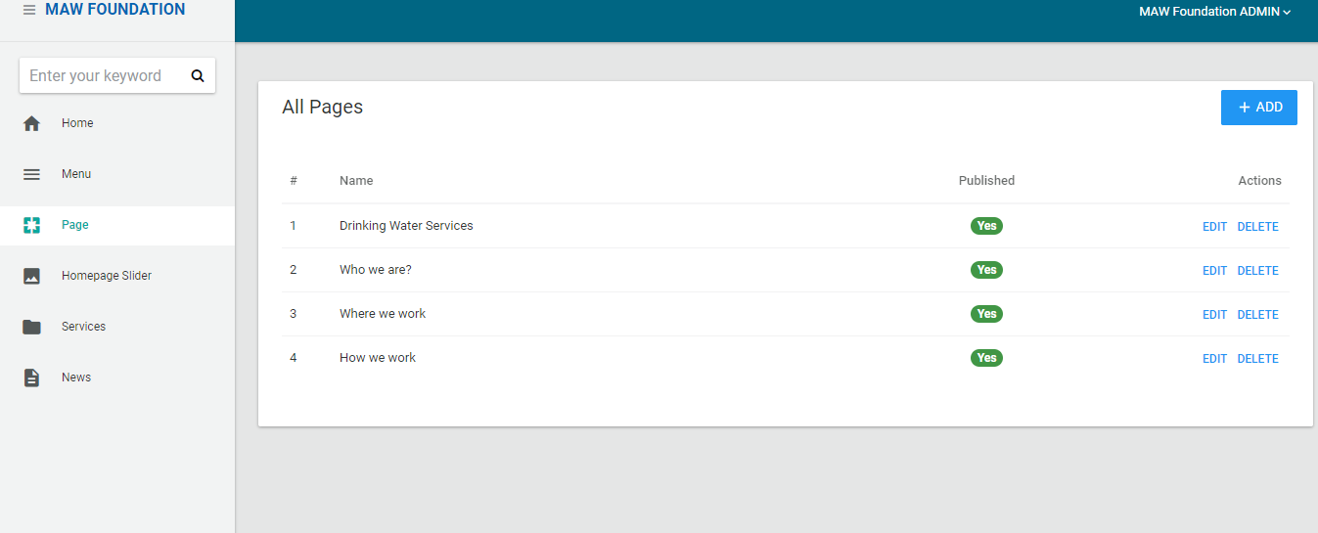

For adding a new page, you can click to “ADD” button and add you required page title, description, content and page image if required. And if you want to edit the page then click to “EDIT” button then you can change the page as per your request.

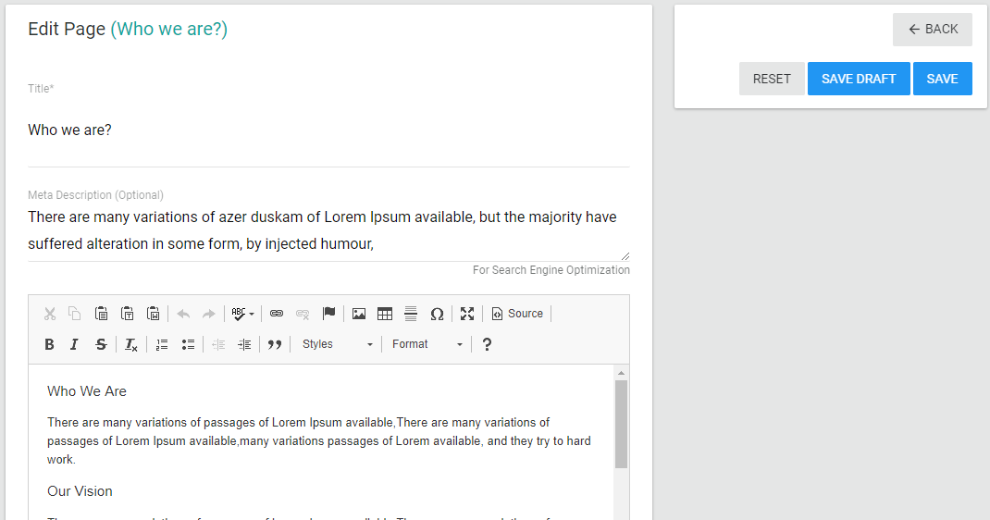

Figure 6: Adding Page

And you can click to “PUBLISH” button for publishing it to the website and if you just want to create a page and do not want to show it on the website then click to “SAVE DRAFT” button.

## Homepage Slider add:

Here by clicking to the Slider, you will be access for creating a new Slider, editing the Slider, and deleting the Slider.

For adding a new Slider, you can click to “ADD” button and add you required Slider title, Caption, URL and page image. And if you want to edit the Slider then click to the image button then you can change the page as per your request.

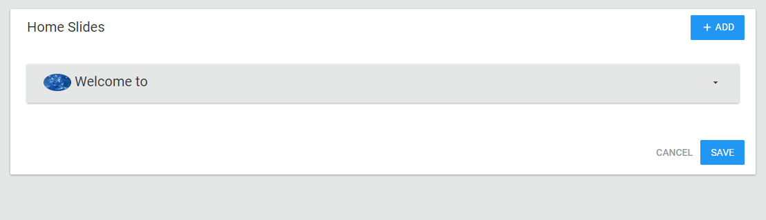

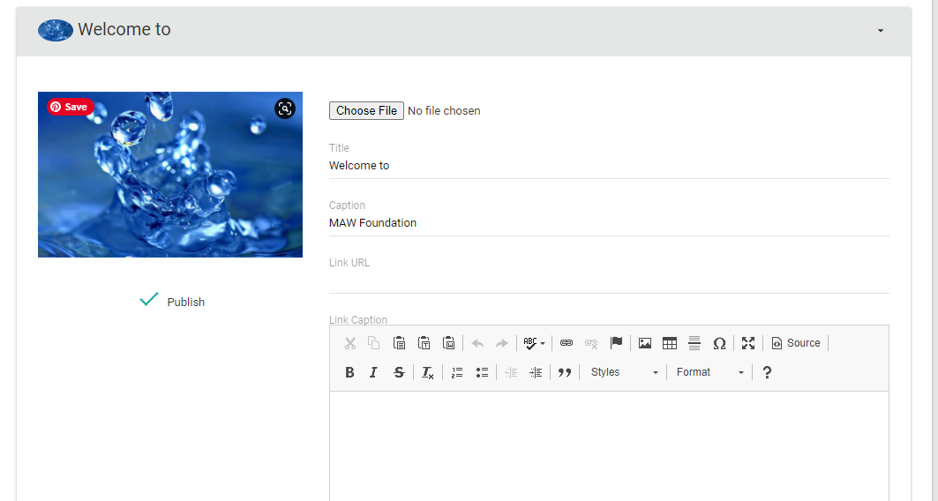

Figure 7: Adding & editing slider

## Services Add:

Here by clicking to the Services, you will be access for creating a new Services, editing the Services, and deleting the Services.

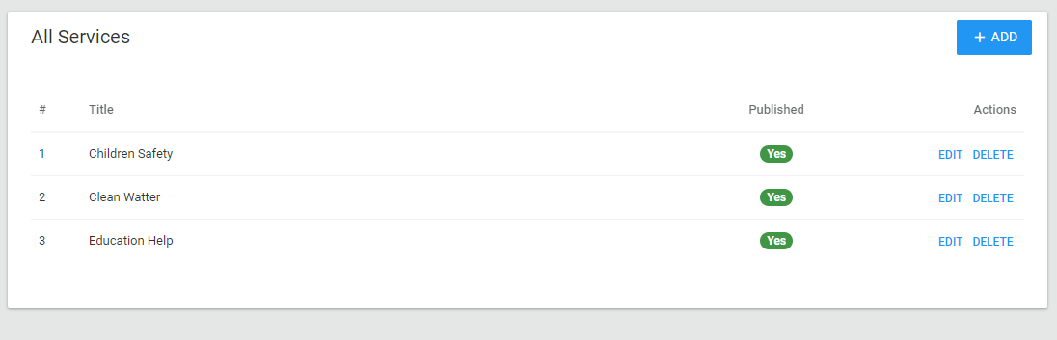

For adding a new Services, you can click to “ADD” button and add you required Services title, description, content and Services image if required. And if you want to edit the Services then click to “EDIT” button then you can change the Services as per your request.

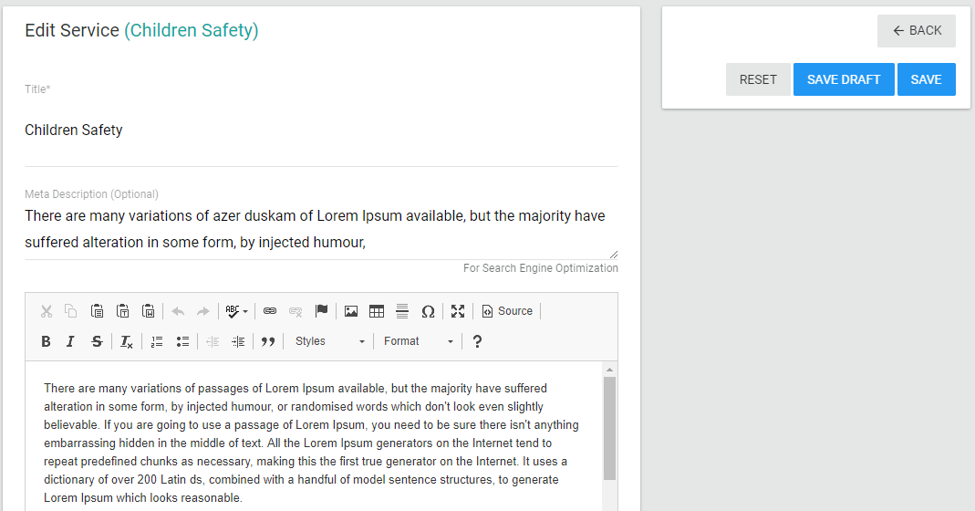

Figure 8: Adding & editing Services

## Setting Changes:

Here by clicking to the setting button you can change the address, phone, email of the website.

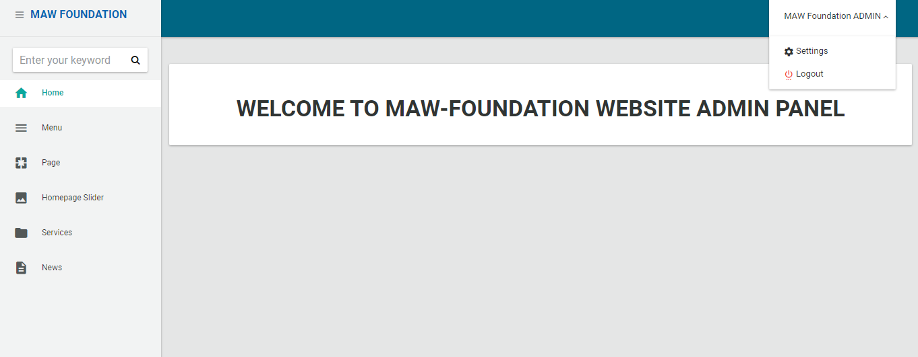

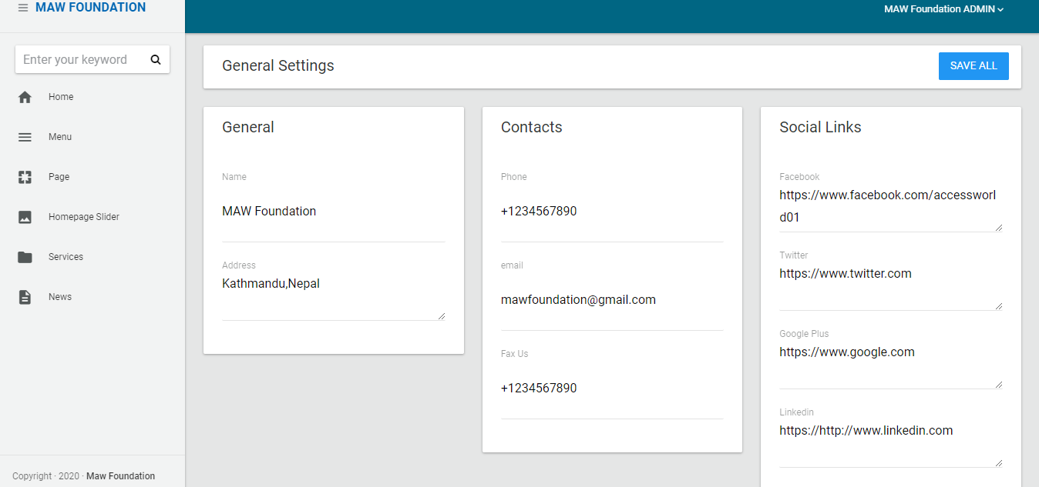

Figure 9: Adding & editing general settings

## Logout:

After the adding and the changes had been made to the website, then you can logout to the dashboard panel of the MAW Foundation website and enter to the frontpage of MAW Foundation.